1] <!DOCTYPE html>

<html>

<head>

<title>About Us</title>

<style>

h1 {

text-align: center;

}

p {

color: darkgray;

font-size: 20px;

}

</style>

</head>

<body>

<h1>About Us</h1>

<p>We are a team of developers building cool stuff.</p>

</body>

</html>

Output:



2] <!DOCTYPE html>

<html>

<head>

<title>Navigation Bar</title>

<style>

nav a {

text-decoration: none;

color: darkblue;

margin-right: 15px; /\* spacing between links \*/

font-size: 18px;

}

nav a:hover {

color: orange;

}

</style>

</head>

<body>

<nav>

<a href="#">Home</a>

<a href="#">About</a>

<a href="#">Contact</a>

</nav>

</body>

</html>

Output: 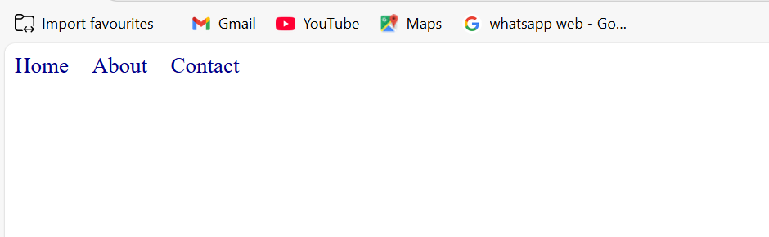

3] <!DOCTYPE html>

<html>

<head>

<title>Box Styling</title>

<style>

.box {

background-color: lightgray;

padding: 20px;

border: 1px solid black;

}

</style>

</head>

<body>

<div class="box">This is a styled box.</div>

</body>

</html>

Output: 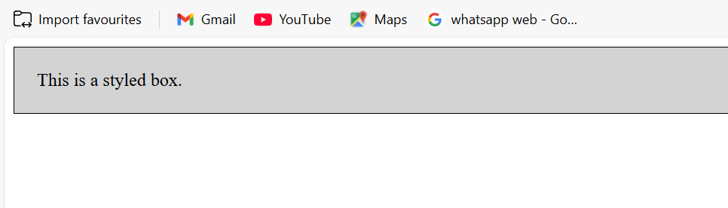

4] <!DOCTYPE html>

<html>

<head>

<title>Button Styling</title>

<style>

.btn {

border-radius: 10px;

padding: 10px 20px;

background-color: #007BFF;

color: white;

border: none;

cursor: pointer;

}

</style>

</head>

<body>

<button class="btn">Submit</button>

</body>

</html>

Output:



5] <!DOCTYPE html>

<html>

<head>

<title>Flexbox Layout</title>

<style>

.container {

display: flex;

justify-content: space-between;

background-color: #f0f0f0;

padding: 20px;

}

.container div {

background-color: #ddd;

padding: 10px;

border: 1px solid #aaa;

}

</style>

</head>

<body>

<div class="container">

<div>Item 1</div>

<div>Item 2</div>

<div>Item 3</div>

</div>

</body>

</html>

Output:

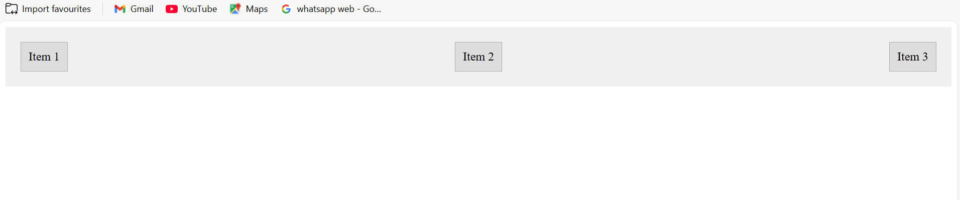

6] <!DOCTYPE html>

<html>

<head>

<title>Hover Card with Shadow</title>

<style>

.card {

border: 1px solid #ccc;

padding: 20px;

transition: box-shadow 0.3s ease;

}

.card:hover {

box-shadow: 0 4px 8px rgba(0, 0, 0, 0.2);

}

</style>

</head>

<body>

<div class="card">

<h3>Samsung Galaxy S23</h3>

<p>Its an android phone with 64MP camera and 6000 mah battery capacity</p>

</div>

</body>

</html>

Output:

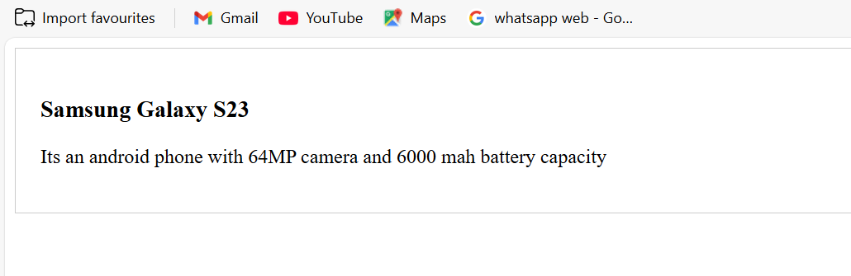

7] <!DOCTYPE html>

<html>

<head>

<title>Even and Odd Row Styling</title>

<style>

table {

width: 100%;

border-collapse: collapse;

}

td {

padding: 10px;

border: 1px solid #ccc;

}

tr:nth-child(odd) {

background-color: white;

}

tr:nth-child(even) {

background-color: #f2f2f2;

}

</style>

</head>

<body>

<table>

<tr><td>Nishmitha</td></tr>

<tr><td>Arshiya</td></tr>

<tr><td>Divya</td></tr>

<tr><td>Rajbala</td></tr>

</table>

</body>

</html>

Output:

